Creating a Shared Access Policy/Key for the Service Bus Namespace

Please, follow the SOP (Steps of Procedure) for the workaround to getting stuck in Section 3. The video has not shown how to create Shared Access Policy Key for your Service Bus Namespace, thus beginners will face an issue with funneling data through the Azure Stream Analytics. The following are the steps to solve this issue.

**Steps of Procedure to Create a  Shared Access Policy**

1. Go to your current Resource Group and select the newly created Service Bus Namespace

2. On the left pane of the Service Bus Namespace, select the “Shared access policies”

3. Now you see a dashboard like shown here

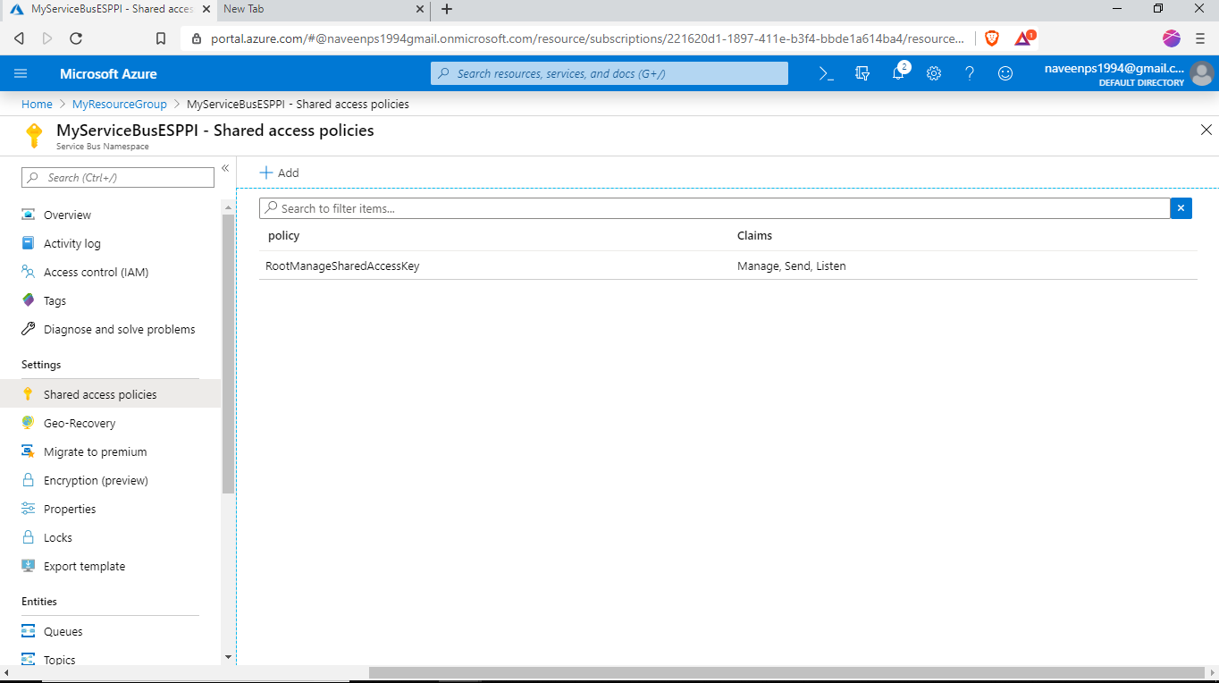

4. You can see that there is a default policy called “RootMangerSharedAccessKey”

5. Now click “Add” and enter a policy name. As per the video I have named it “TriggerActionPolicy”. Then Select Manage, which will by default select the “Send” and “Listen” options. Finally, select “create” to create the policy.

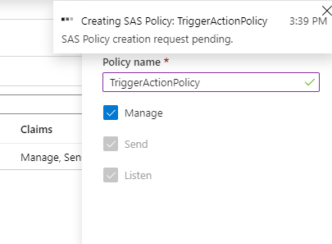

6. Now you can continue with Video 3.3 till 2:40 where the Client Device Code is explained.

7. At 2:40 the instructor will ask you to copy & paste the details for your Service Bus Details to the code.

8. Type your Service bus namespace in the first place holder

9. Type your Service bus shared access policy name to the second place holder

10. Now in the shared access policies tab click the newly created policy and a popup window will slide from the right side. From this pane copy the Primary key and paste it in the Third placeholder in the client end code.

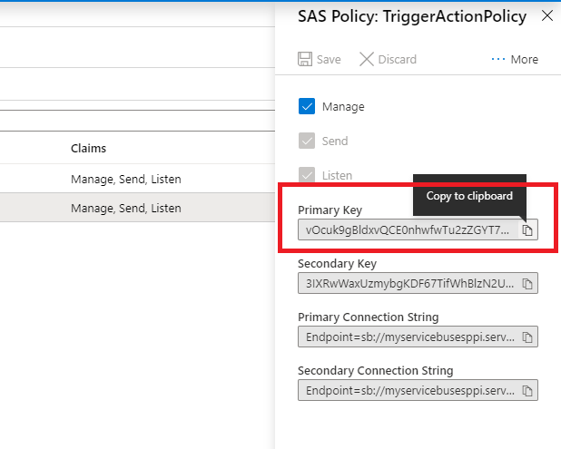

11. Now you can continue from 2:59 of Video 3.3

Please note that once the Version 2 SDK is out of preview and gets fully released, you might need to migrate the codes in the course to the new version, when the cloud services stop support for old SDK APIs. The documentation to help you out [with the migration is here.](https://github.com/Azure/azure-iot-sdk-python/blob/master/migration_guide.md)